**EXPERIMENT NUMBER 6**

| Name of Student: Sangeet Agrawal | PRN: 21070122140 | Section: CS-B3 |
| --- | --- | --- |

**Title:** Hashing - one-way randomness in hash-function.

**Aim:** Study, understand and demonstrate hash function and its tool

**Objective:** To make students understand and demonstrate hash function and security benefit of hashing in encryption-decryption

**Theory:**

1. **Hash function:** A function that maps a message of any length into a fixed-length hash value, which serves as the authenticator
2. A variation on the message authentication code is the one-way hash function.
3. As with the message authentication code, a hash function accepts a variable-size message *M* as input and produces a fixed size output, referred to as a **hash code** H(*M*).
4. Unlike a MAC, a hash code does not use a key but is a function only of the input message.
5. The hash code is also referred to as a **message digest** or **hash value**.
6. The hash code is a function of all the bits of the message and provides an error-detection capability: A change to any bit or bits in the message results in a change to the hash code.

**Simple Hash Function – Type I**

1. All hash functions operate using the following general principles.
2. The input (message, file, etc.) is viewed as a sequence of *n*-bit blocks. The input is processed one block at a time in an iterative fashion to produce an *n*-bit hash function.
3. One of the simplest hash functions is every block's bit-by-bit exclusive-OR (XOR).
4. This operation produces a simple parity for each bit position, known as a longitudinal redundancy check.

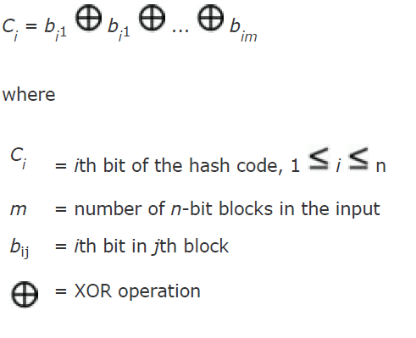

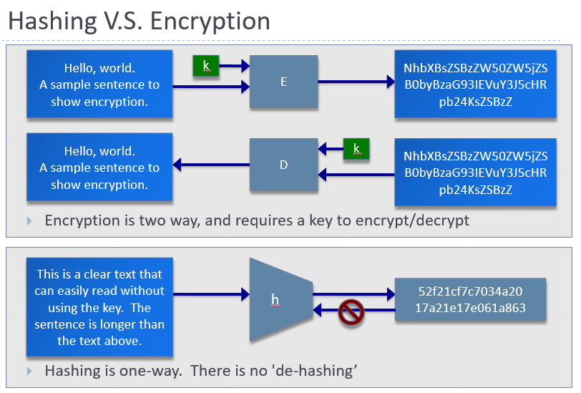

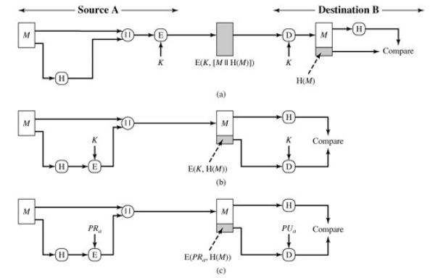

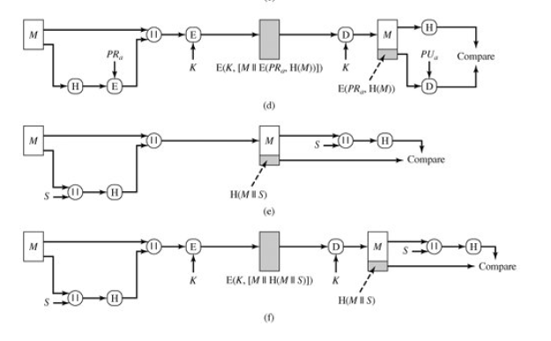

**Figure: Basic Uses of Hash Function**

**[Source: Cryptography and Network Security: Principles and Practice by William Stallings]**

**Tools to be practiced:**

1. Assignment from Cryptography Virtual Lab (website link 1)
2. HashCalc
3. MD6 Hash Generator
4. All Hash Generator
5. HashMyFiles
6. Some mobile hash calculation tools

**Reference web links:**

1. <https://cse29-iiith.vlabs.ac.in/>
2. <https://www.nirsoft.net>
3. <https://convert-tool.com>
4. <https://www.slavasoft.com>
5. <https://onlinehashtools.com>
6. <https://www.devglan.com/cryptotools/cryptography-tools>
7. <https://www.browserling.com>

**Conclusion:**

**Implementation question:**

1. Demonstrate any other two free cryptography tools based on hash function
2. Perform 1 assignments from virtual lab based on hash function
3. Study and differentiate between MD5 and Hash.

**Note:** Students are suggested to use Linux OS based tools or free Windows OS based tools.

1. MD4 Hash: <http://www.practicalcryptography.com/hashes/md4-hash/>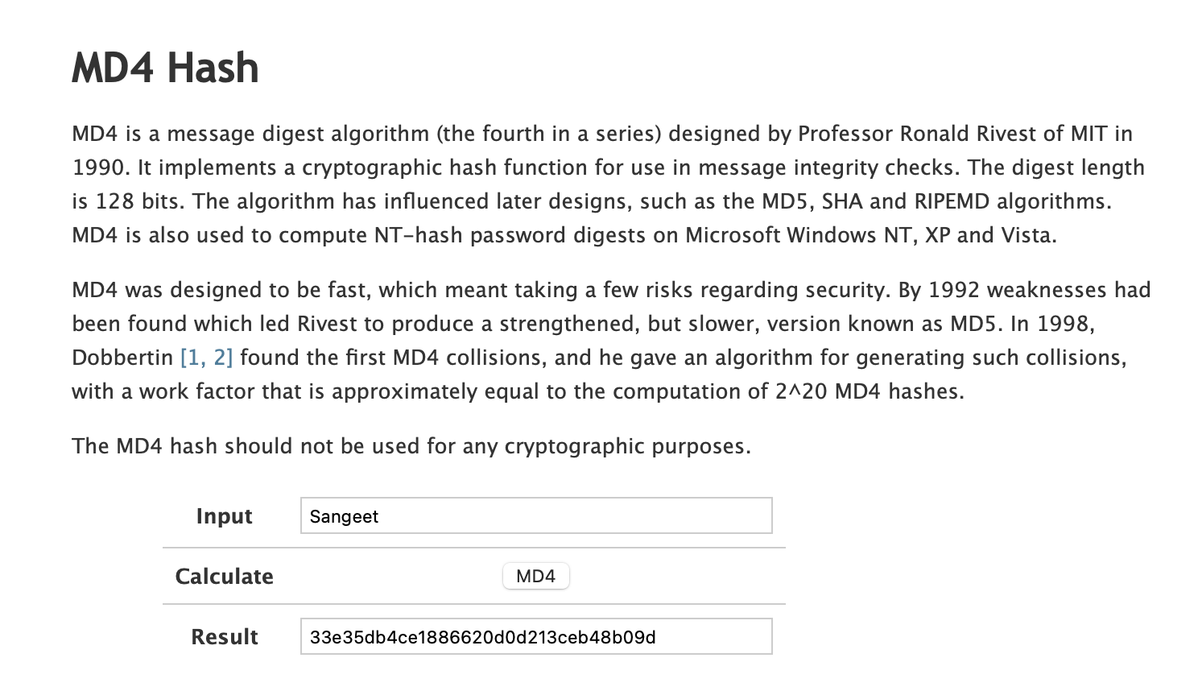

MD5 Hash: <https://www.md5online.org/md5-encrypt.html>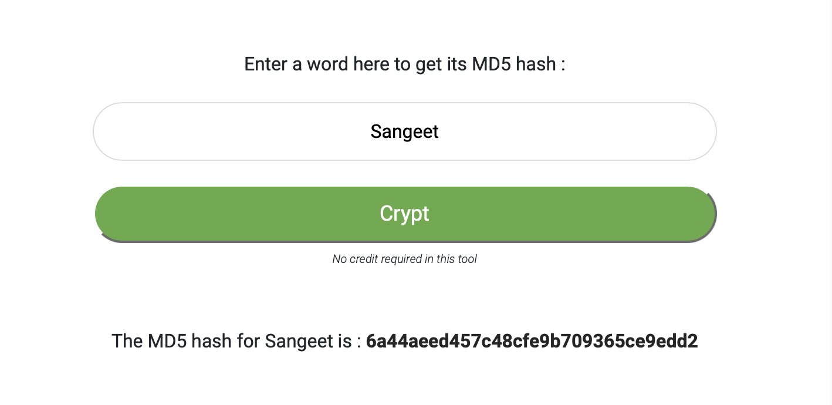

1. Simulation: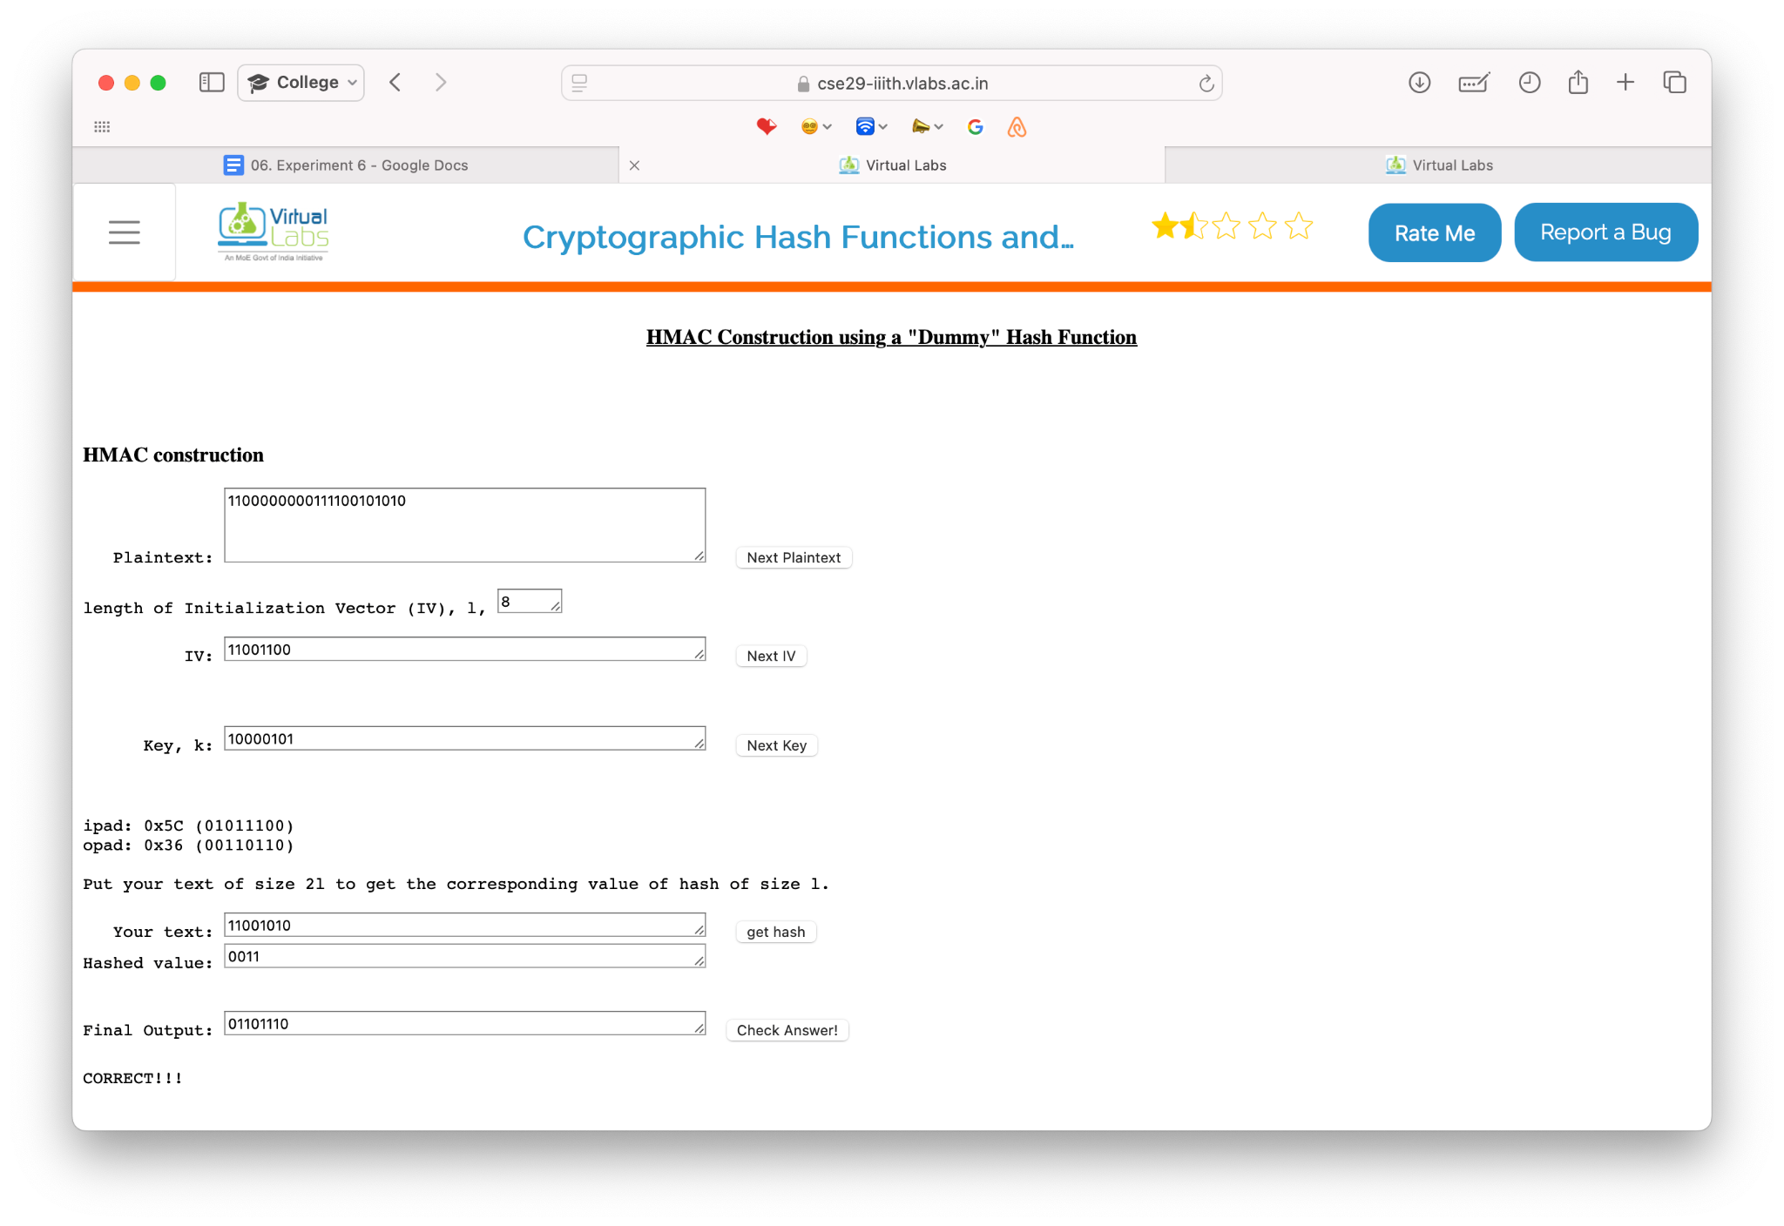

Assignment: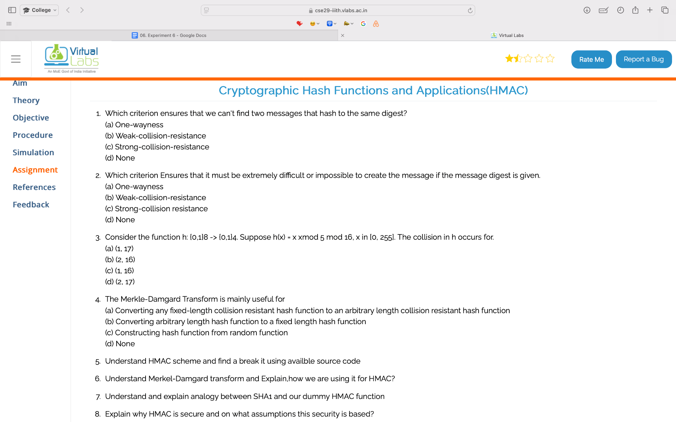

Answers:

1. (c) Strong-collision-resistance
2. (a) One-wayness
3. (c) (1, 16)
4. (a) Converting any fixed-length collision-resistant hash function to an arbitrary-length collision-resistant hash function
5. **Breaking HMAC:** HMAC relies on a secure hash function; breaking it is difficult unless the hash function is weak.
6. **Merkle-Damgård in HMAC:** Used to extend fixed-length hash functions to variable-length inputs, ensuring efficient hashing in HMAC.
7. **SHA-1 and Dummy HMAC Analogy:** Both involve hashing in multiple rounds with compression functions and padding.
8. **HMAC Security:** Secure due to the use of a secret key and a collision-resistant hash function. Security assumes the hash function is strong and the key is secret.
9. Differentiating between MD5 and Hash:

| **Features** | **MD5** | **General Hash Function** |
| --- | --- | --- |
| **Output Size** | 128-bit | Varies (e.g., 256-bit for SHA-256) |
| **Speed** | Fast | Varies by algorithm |
| **Security** | Vulnerable to collision attacks | Depends on algorithm (e.g., SHA-256 is secure) |
| **Use Cases** | Checksums, file integrity (non-critical) | Cryptography, digital signatures, data integrity |
| **Current Relevance** | Considered insecure | Modern algorithms (like SHA-256) are secure and widely used |